**Graph Valid Tree:**

You have a graph of n nodes labeled from 0 to n - 1. You are given an integer n and a list of edges where edges[i] = [ai, bi] indicates that there is an undirected edge between nodes ai and bi in the graph.

Return true *if the edges of the given graph make up a valid tree, and* false *otherwise*.

**Example 1:**

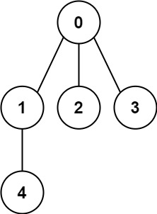

**Input:** n = 5, edges = [[0,1],[0,2],[0,3],[1,4]]

**Output:** true

**Example 2:**

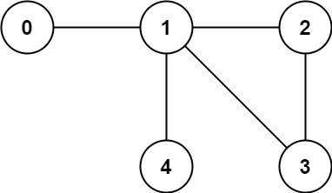

**Input:** n = 5, edges = [[0,1],[1,2],[2,3],[1,3],[1,4]]

**Output:** false

**Constraints:**

* 1 <= 2000 <= n
* 0 <= edges.length <= 5000
* edges[i].length == 2
* 0 <= ai, bi < n
* ai != bi
* There are no self-loops or repeated edges.